NEXUS COGNITIVE KERNEL
Complete Architecture Documentation

1. System Overview and Architecture Philosophy

The NEXUS Cognitive Kernel is the central coordination layer of an agentic operating system designed to manage multiple AI agents executing complex, multi-step goals concurrently. It is not an AI system itself. It does not reason about goals, make LLM calls, or decide what an agent should do. Its job is purely mechanical: accept goals, decompose them into a dependency graph, dispatch agents against that graph, enforce resource limits, and ensure the system can always be recovered from any failure state. This separation of concerns — between cognition (done by agents) and coordination (done by the kernel) — is the foundational design decision from which every other decision follows.

The system operates across three nested boundaries. At the outermost boundary is the NEXUS Agentic OS, which contains everything. Inside it sits the Cognitive Kernel, which is the subject of this document. Below the kernel lives the Agent Space, populated by specialized agents including the Planner, Contextualizer, UITARSAgent, SpecialistAgents, and background agents like Chronicler and Consolidator. Orthogonal to both is the Security Kernel, which handles semantic consistency checking, action gating, and audit logging — responsibilities the Cognitive Kernel explicitly refuses to absorb.

The kernel is implemented as a single OS process containing multiple threads sharing one address space. This is the monolithic kernel model, chosen deliberately over a microkernel approach. The reasoning is identical to why Linux chose monolithic architecture over the microkernel Tanenbaum advocated for in 1992: every subsystem communication becomes a direct function call rather than an IPC message with serialization overhead. Against an inference background of 2,000 to 8,000 milliseconds per LLM call, the difference between nanosecond function calls and microsecond IPC messages accumulates into meaningful latency at scale.

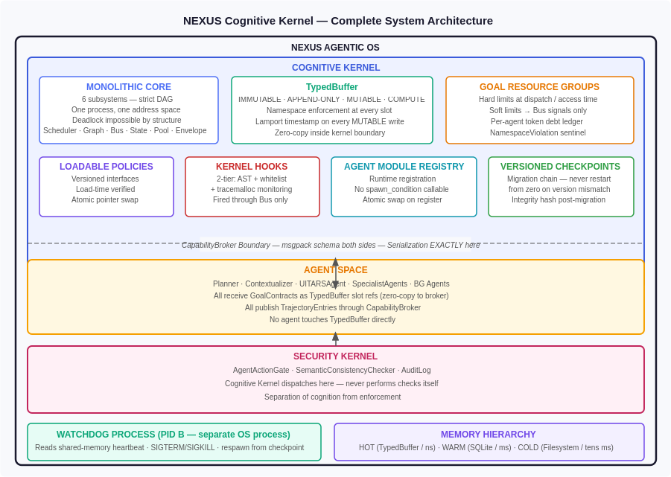
Figure 1: NEXUS Agentic OS — Complete System Architecture showing all boundary layers and component relationships

The diagram above shows the three primary boundary layers: the Cognitive Kernel containing the Monolithic Core and its supporting structures, the Agent Space below the CapabilityBroker serialization boundary, and the Security Kernel as an orthogonal enforcement layer. The Watchdog Process operates as a separate OS process with its own address space — immune to any freeze condition in the main kernel process — and is responsible for detecting and recovering from kernel-level stalls via a shared-memory heartbeat protocol.

Thread | Lives In | Priority | Stall Immunity | Notes
Main kernel event loop | PID A | Native OS | RWLock timeout + async CPUPool + hook pool | Emits heartbeat every 1s. All 3 stall paths eliminated.
EnvelopeMonitor | PID A | 200ms timer | Pure arithmetic, no I/O | Fires every 200ms. Computes progress_ratio and consumption_ratio.
EnvironmentOracle | PID A | 200ms poll | Lightweight OS calls via Tool Factory | Polls machine state. Publishes ChangeEvents with causal attribution.
CPUWorkerPool (N threads) | PID A | Low OS (nice=10) | Own GIL. On completion: publishes to Bus | Handles CPU-bound work. Completion via Bus callback, never blocking return.
Hook Thread Pool (2–3 threads) | PID A | Normal | 1ms timeout per hook; timeout: deregister hook | NEW: eliminates SP-3 stall path. Publisher never blocked by hook behavior.
Event Log Flush | PID A | BG | 500ms batch write to SQLite | No impact on main thread. Drains APPEND_ONLY_REGION to SQLite.
VirtualDisplay Replenishment | PID A | BG | Reactive — sleeps most of time | Wakes when idle pool drops to 0. Spawns pre-warmed Xvfb displays.
Agent Health Watchdog (L1) | PID A | Normal | 5s poll of agent_registry | Monitors AGENTS ONLY. Not kernel. L2 (separate process) monitors kernel.
Kernel Health Watchdog (L2) | PID B (separate) | Native OS process | Completely separate address space, separate GIL | Cannot be frozen by kernel stall. Reads shared-memory heartbeat. 5-step recovery.
Agent threads (transient) | PID A | Per priority class | Spawned per agent, terminated on completion | Blocked on LLM calls (GIL released). One thread per running sub-goal.

Six architectural principles govern every design decision in this system. First: mechanism is monolithic, policy is modular. The core scheduling and dispatching logic is fixed and centralized, but every policy decision — how to score a resource, when to declare an agent stalled, what to do when a budget anomaly is detected — lives in a versioned loadable module. This means deployments can tune behavior without modifying or restarting the kernel. Second: isolation is achieved by data structure, not process boundary. TypedBuffer regions, namespace enforcement, and the CapabilityBroker boundary replace inter-process communication as the isolation mechanism. Third: CRITICAL preemption is absolute. No weighting, no exceptions, no cross-queue interference. Fourth: enforcement happens at construction, not at detection. Limits are imposed at the moment a goal is created, at the moment a dispatch is attempted, at the moment a slot is accessed — not discovered after violation. Fifth: every interface and every checkpoint is versioned with a migration path. Sixth: structure serves debuggability. Every failure in this system must be diagnosable in minutes, not hours.

2. Monolithic Core — Six Subsystems and the Scheduler

The Monolithic Core is the heart of the Cognitive Kernel. It consists of six subsystems — the Scheduler, the Graph Subsystem, the Shared Memory Bus, the StateManager, the CPUWorkerPool, and the PolicyDispatcher — arranged in a strictly directed acyclic call graph. Deadlock is impossible not because of careful discipline but because no cycle can exist in the call graph by construction. The Bus never calls back to any core subsystem. The CPU Worker Pool publishes to the Bus asynchronously rather than waiting for acknowledgment. No subsystem holds a lock while calling another subsystem.

Six Subsystems — Call Relationships
Subsystem | Calls Into | Key Responsibility
Scheduler | PolicyDispatcher, TokenManager, PoolManager | Dispatches resource calls; owns ResourceRegistry and DynamicQueueSet
Graph Subsystem | Scheduler (on unblocking events) | Stores GoalDependencyGraph; triggers O(N) unblocking check on TrajectoryEntry
StateManager | CPUWorkerPool (async), Bus | Writes to TypedBuffer; dispatches snapshot construction non-blocking
Bus | Registered hook handlers only | Lamport clock authority; synchronous dispatch in publisher thread; never calls back to core subsystems
CPUWorkerPool | Bus (async) | Handles CPU-bound work; dispatched async by StateManager; publishes WORLD_MODEL_READY to Bus on completion
PolicyDispatcher | called by Scheduler | Versioned policy module loading; safety contract tests; atomic pointer swap on approval

The Scheduler is the most complex of the six subsystems. It manages a dynamic set of per-resource-type queues, created on first registration of each resource type. The current resource types are VISUAL (for UITARSAgent visual inference models), TEXT (for language model calls), EMBED (for embedding model calls), and LOCAL (for on-device models). The architecture anticipates AUDIO and future modality types by creating queues dynamically rather than hardcoding resource type enumeration.

Strict Call Graph — No Cycles, No Exceptions
Scheduler | Dispatcher direction only: Scheduler → PolicyDispatcher, TokenManager, PoolManager
Graph → Scheduler | Only on unblocking events (when a PENDING node becomes executable)
StateManager → Bus | Dispatches async to CPUWorkerPool; subscribes to WORLD_MODEL_READY event
EnvelopeMonitor → Bus | Publishes signals only. The Bus dispatches to registered handlers, never back to core subsystems

Each resource in the registry carries five fields: a capacity integer representing concurrent call slots, a current_load AtomicInt tracking active dispatches, an avg_lat_ms field maintained as an Exponential Moving Average, a p95_lat_ms reservoir for tracking predictability, and a cost_per_1k float and canary_weight float for the scoring function. These fields are read by the score function during every dispatch decision.

Per-Resource Fields
capacity: int | Maximum concurrent in-flight calls
current_load: AtomicInt | Live count of in-flight calls — atomic, no lock
avg_lat_ms: EMA | Exponential moving average latency; alpha configurable per priority class
p95_lat_ms: reservoir | Reservoir sampled; used for BG calls to prefer predictable resources
cost_per_1k: float | Token cost; used in score function; weight configurable per deployment
canary_weight: float | Traffic-limits new model versions without a separate routing layer

Within each per-resource queue, scheduling operates across two levels that are never mixed. Level 1 enforces absolute priority class ordering: CRITICAL (class 0) always before PLANNING (class 1), PLANNING always before EXECUTION (class 2), EXECUTION always before BG (class 3). This ordering has no exceptions and admits no weighting. A BG job will never execute while a CRITICAL job is waiting on the same resource queue, regardless of how long the BG job has been waiting, regardless of how much the CRITICAL job has consumed in prior calls.

Level 2 scheduling operates within each priority class using Virtual Inference Time, computed as tokens_consumed divided by priority_weight. The weights are CRITICAL=4.0, PLANNING=2.0, EXECUTION=1.0, and BG=0.25. The agent with the lowest virtual inference time within its class runs next. New arrivals to a class start at the minimum virtual inference time of all agents currently in that class, never at zero. This prevents any agent from dominating through late arrival and ensures fairness within each priority class without allowing cross-class interference.

An important subtlety: cross-queue priority is explicitly not applied. A CRITICAL goal waiting on the EMBED queue does not preempt a BG goal executing on the TEXT queue. The resources are genuinely different hardware. Priority applies within a resource type only. A CRITICAL goal that needs both VISUAL and TEXT resources jumps to the front of both queues independently and then waits for whichever of the two completes last. This is correct behavior. It is unavoidable given the hardware architecture.

Two-Level Queue Structure (Identical for All Resource Types)
Level 1 — Absolute Priority Class | CRITICAL(0) > PLANNING(1) > EXECUTION(2) > BG(3)No exceptions. No cross-class weighting. Enforced before any other decision.
Level 2 — Virtual Inference Time | virt_inf_time = tokens_consumed / priority_weightWeights: CRITICAL=4.0, PLANNING=2.0, EXECUTION=1.0, BG=0.25Lowest virt_inf_time in class runs next. New arrival starts at MIN of class.
Cross-Queue Priority | Explicitly does NOT apply. CRITICAL on EMBED does not preempt BG on TEXT.Resources are genuinely different hardware. Priority applies within resource type only.
Multi-Resource CRITICAL Goal | Jumps to front of EACH relevant queue independently.Waits for slower of the two — correct and unavoidable.

DYNAMIC QUEUE SET AT RUNTIME
════════════════════════════════════════════════════════════════════
ResourceRegistry QueueSet
───────────────── ──────────────────────────────────
uitars-1 VISUAL cap=1 ──┐
uitars-2 VISUAL cap=1 ──┼──► VISUAL queue [two-level algorithm]
claude-op TEXT cap=10 ──┐
claude-sn TEXT cap=20 ──┼──► TEXT queue [two-level algorithm]
embed-lg EMBED cap=50 ──┼──► EMBED queue [two-level algorithm]
local-q LOCAL cap=1 ──┼──► LOCAL queue [two-level algorithm]
[AUDIO TBD] ──────── ──► AUDIO queue (created on registration)

Each queue is IDENTICAL in structure.
Priority is enforced WITHIN each queue, NEVER across queues.
CRITICAL on EMBED does NOT preempt BG on TEXT.
Resources are genuinely different hardware.
Fig 5.1 — Dynamic Queue Set — queues created on first backend registration. No cross-queue priority.

Preemption Model
The preemption model is honest about its limitations. When a CRITICAL job arrives and the resource is occupied, the in-flight call is allowed to complete. HTTP requests to remote LLM endpoints cannot be recalled. The CRITICAL job jumps to the front of Level 1 and is dispatched immediately upon the in-flight call completing. The displaced job is re-queued at the front of its own priority class — it is never killed, only delayed.

Preemption means queue position change only, never call cancellation.

CRITICAL arrives, resource free | Dispatch immediately
CRITICAL arrives, resource busy | Jump to the front of Level 1. In-flight call completes. CRITICAL dispatched on completion. The victim re-queues in front of its own class — never killed.
This is about what happens to the task that gets bumped when a CRITICAL goal arrives.
The scenario:
A BG (background) goal is currently executing an API call. Mid-way through, a CRITICAL goal arrives and jumps to the front of the queue.
"The victim" = that BG goal that got bumped.
The key thing to understand first: the in-flight HTTP request to the LLM cannot be cancelled. Once you've sent a request to Claude or UI-TARS, you can't take it back mid-flight. So the BG goal's current API call finishes naturally — the CRITICAL goal just waits for it to complete, then gets dispatched immediately after.
After that BG call completes, the BG goal still has more work to do. So where does it go?
- It goes back into the queue — it's not abandoned or terminated
- It goes to the front of its own priority class (BG class in this case) — so it doesn't lose its place to other BG goals that arrived after it
- But it still sits below CRITICAL and PLANNING and EXECUTION goals — it doesn't get elevated

So "never killed" just means the goal isn't terminated or lost. It keeps its progress, keeps its state, and will eventually get to continue — just after the more urgent work is done.
PREEMPTION MODEL (honest — accounts for HTTP in-flight constraint)
════════════════════════════════════════════════════════════════════

CRITICAL arrives while resource is fully loaded:
1. Jump to front of Level 1 (priority class 0)
2. In-flight call COMPLETES — cannot cancel HTTP request mid-flight
3. CRITICAL dispatched immediately on completion
4. Victim re-queues at front of ITS class — never killed, never penalized

Preemption = queue position change only.
NOT: cancellation of executing calls.
NOT: interruption of running inference.

Practical implication:
CRITICAL may wait up to MAX_INFLIGHT_LATENCY for a slot to free.
This is bounded and known. An unbounded wait cannot happen because
in-flight calls always complete (or timeout with circuit breaker).

CROSS-QUEUE INVARIANT: Priority applies within a resource type, NEVER across.
CRITICAL on EMBED does NOT preempt BG on TEXT.
These are genuinely different hardware with independent queues.
Fig 5.3 — Preemption model: queue position change only, never in-flight cancellation.

Score Function for Resource Selection
The score function used to select among available resources for a given task type reads from the SchedulingPolicy module, making all weights configurable per deployment. A cost-sensitive deployment sets high weight on w_cost. A latency-sensitive deployment sets high weight on w_lat. The EMA alpha values differ by priority class: CRITICAL calls use alpha=0.5 for fast decay to detect resource degradation immediately and reroute, while BG calls use alpha=0.1 to avoid thrashing routing decisions on temporary spikes. The canary_weight field on individual resources naturally limits traffic to canary deployments without requiring a separate routing layer.
You have multiple resources of the same type. For example in the TEXT category you have:
- claude-op (capacity 10)
- claude-sn (capacity 20)
When a TEXT task arrives, the kernel needs to decide which one to actually send the API call to. The score function makes that decision.
When multiple backends serve the same resource type (e.g., claude-opus and claude-sonnet both serve TEXT), the scheduler uses a scoring function to select which backend to route to. All weights live in the SchedulingPolicy module and are hot-swappable without restart:

# Backend selection score function
# Runs per-backend when resource type has multiple registered backends
def score(backend, priority_class, scheduling_policy) -> float:
# Latency input depends on priority class
if priority_class == CRITICAL:
latency_input = backend.avg_lat_ms # EMA alpha = 0.5 (fast decay)
elif priority_class == BG:
latency_input = backend.p95_lat_ms # use p95 — prefer PREDICTABLE
else: # PLANNING, EXECUTION
latency_input = backend.avg_lat_ms # EMA alpha = 0.1 (medium decay)

w_lat = scheduling_policy.w_lat # latency weight
w_load = scheduling_policy.w_load # load weight
w_cost = scheduling_policy.w_cost # cost weight

raw_score = (w_lat * (1.0 / latency_input))
+ (w_load * (1.0 - (backend.current_load / backend.capacity)))
+ (w_cost * (1.0 / backend.cost_per_1k))

# Canary multiplication: naturally limits canary traffic
# No separate traffic router needed; canary weight IS the router
return raw_score * backend.canary_weight

# Tuning examples (all in SchedulingPolicy module):
# Cost-sensitive: high w_cost → choose cheapest backend
# Latency-sensitive: high w_lat → choose fastest backend
# Throughput-max: high w_load → choose least-loaded backend

score = (w_lat × 1/latency_input) + (w_load × 1 - load/capacity) + (w_cost × 1/cost_per_1k) × canary_weight | All weights live in the SchedulingPolicy module — configurable per deployment.
latency_input for CRITICAL | avg_latency_ms with α=0.5 (fast decay — detect degradation immediately)
latency_input for BG | p95_latency_ms (prefer predictable resources)
latency_input for PLANNING/EXECUTION | avg_latency_ms with α=0.2 (medium decay)
Cost-sensitive deployment | Raise w_cost
Latency-sensitive deployment | Raise w_lat

The exponential moving average alpha for latency tracking differs by priority class, reflecting the different sensitivity requirements of each class:

Priority Class | EMA Alpha | Rationale
CRITICAL (0) | 0.5 (fast decay) | Detect latency degradation immediately; reroute before next CRITICAL call pays the cost. Fast decay sacrifices smoothness for responsiveness.
PLANNING (1) | 0.2 (medium) | Stable enough for planning calls which tolerate 200–800ms; avoids thrashing on temporary spikes.
EXECUTION (2) | 0.2 (medium) | Same as PLANNING; execution agents tolerate similar latency variance.
BG (3) | 0.1 (slow decay) | BG calls (Consolidator, WorldBuilder) prefer stable routing; avoid thrashing based on momentary spikes. Uses p95 not avg for predictability.

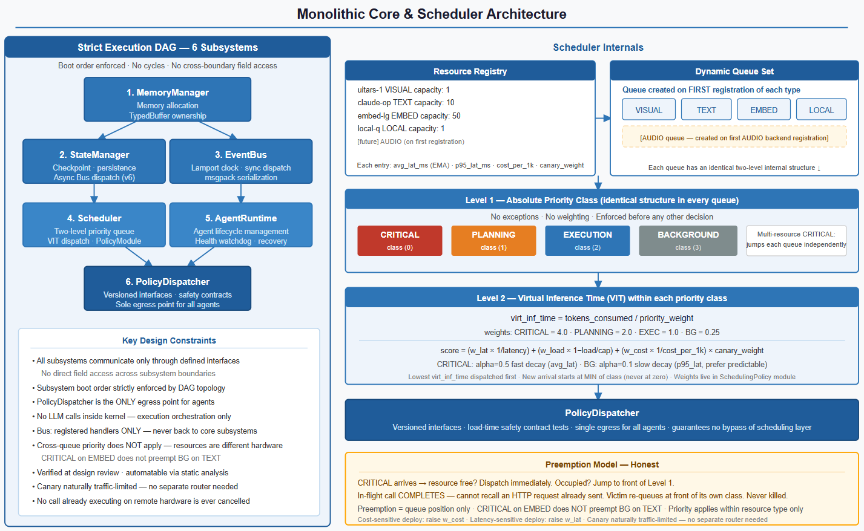

Figure 2: Monolithic Core — Six subsystems, Scheduler internals, two-level queue structure, thread map, and call DAG

The call DAG shown in the diagram above is the enforcement mechanism for deadlock impossibility. The Scheduler calls the PolicyDispatcher, the TokenManager, the PoolManager, the Graph Subsystem, and the Bus. The StateManager calls the CPUWorkerPool asynchronously and publishes to the Bus. The EnvelopeMonitor publishes signals to the Bus. The Bus dispatches to registered handlers only — never back to any core subsystem. This means there is no path by which a subsystem can be called from below, which means there is no cycle, which means deadlock by circular wait is structurally impossible.

The PolicyDispatcher
All policy modules are versioned interfaces. SchedulingPolicy_v1 declares score(call, resource, virt_time_table) → float, should_preempt(incoming_pri, running_pri) → bool, and configurable weights for latency, load, cost, and per-priority-class EMA decay alphas. HealthPolicy_v1 declares is_stalled(heartbeat_age_ms, agent_type, goal_pri) → bool and recovery_action(agent, fail_count) → SOFT | HARD | ESCALATE. EnvelopePolicy_v1 declares handle_anomaly(signal, goal, progress, completion_prob) → CONTINUE | EXTEND | TERMINATE | ESCALATE. ObservationPolicy_v1 declares should_update(event_batch) → bool and merge_priority(events) → filtered event list.
Loading a module follows a strict three-step protocol. Step 1 — version check: policy_dispatcher.load(module, declared_interface_version) checks the declared version against the registry's current interface version. Any mismatch is a hard reject with an explicit version mismatch message. Step 2 — safety contract tests: for SchedulingPolicy modules, the dispatcher runs a fixed test suite verifying that the module respects the fundamental priority ordering that must hold regardless of any other policy logic. should_preempt(CRITICAL, EXECUTION) must return True. should_preempt(CRITICAL, BG) must return True. should_preempt(CRITICAL, PLANNING) must return True. should_preempt(BG, CRITICAL) must return False. should_preempt(EXECUTION, CRITICAL) must return False. Any failure rejects the module with the specific failing test case named — not a generic error. Step 3 — atomic installation: a module that passes all tests is installed via atomic pointer swap replacing the old module pointer. In-flight scheduling decisions complete against the old policy. The next decision uses the new one. The old module is garbage-collected by Python reference counting.
The safety contract tests are like a checklist the app runs before activating any plugin. For scheduling policies specifically, the system is verifying that the new policy respects the basic rules of priority — things that must always be true no matter what the policy does otherwise:
- CRITICAL should always beat EXECUTION ✓
- CRITICAL should always beat BACKGROUND ✓
- CRITICAL should always beat PLANNING ✓
- BACKGROUND should never beat CRITICAL ✓
- EXECUTION should never beat CRITICAL ✓
If the new policy fails even one of these, it gets rejected and the error tells you exactly which test failed — not just "something went wrong."

Versioned Policy Interfaces
Interface | Methods / Fields | Returns
SchedulingPolicy_v1 | score(call, resource, virt_time_table) | float
 | should_preempt(incoming_pri, running_pri) | bool
 | weight_latency, weight_load, weight_cost: float | —
 | alpha_critical=0.5, alpha_execution=0.2, alpha_bg=0.1 | —
HealthPolicy_v1 | is_stalled(heartbeat_age_ms, agent_type, goal_pri) | bool
 | recovery_action(agent, fail_count) | SOFT | HARD | ESCALATE
EnvelopePolicy_v1 | handle_anomaly(signal, goal, progress, completion_prob) | CONTINUE | EXTEND | TERMINATE | ESCALATE
ObservationPolicy_v1 | should_update(event_batch) | bool
 | merge_priority(events) | [event]

Module Load Protocol
Version check | declared_interface_version == registry's current interface version?NO → HARD REJECT with explicit version mismatch message.
Safety contract tests (SchedulingPolicy) | should_preempt(CRITICAL, EXECUTION) == Trueshould_preempt(CRITICAL, BG) == Trueshould_preempt(CRITICAL, PLANNING) == Trueshould_preempt(BG, CRITICAL) == Falseshould_preempt(EXECUTION, CRITICAL) == FalseAny failure → REJECT naming specific test.
On approval | Atomic pointer swap: old module ptr → new module ptr.In-flight scheduling decisions complete against old policy.Next scheduling decision uses new policy.Old module garbage-collected by Python refcount.

3. TypedBuffer — Shared Memory Architecture

TypedBuffer is the shared memory backbone of the Cognitive Kernel. It is a single pre-allocated region divided into four zones, each with its own concurrency protocol precisely matched to its access pattern. All objects inside TypedBuffer are native Python objects — no serialization, no copying within the kernel boundary. The only serialization in the entire system happens at the CapabilityBroker boundary when passing GoalContracts to agents and receiving TrajectoryEntries back. This zero-copy design is the reason kernel-internal operations run at nanosecond to microsecond latency while the external LLM calls that dominate total execution time run at seconds.

The COMPUTE_REGION in TypedBuffer has three slots :

COMPUTE_REGION Slot | Written By | Read By | Protocol
capability_matrix (numpy float32 app capability vectors) | CPU Worker Pool at startup and on 5-min MachineProfile refresh. | Contextualizer (app capability ranking). | Exclusive access by protocol. Contextualizer requests read slot from CPU Worker Pool via Bus message. No lock; coordination by message.
hnsw_index (in-memory semantic search index) | CPU Worker Pool after each Consolidator run rebuilds warm-tier index. | Contextualizer (ANN semantic search before sqlite-vec query). | Same exclusive access protocol. Updated atomically after warm-tier index rebuild.
embedding_cache ({text_hash → float32 vector}) | Any component that computes a new embedding (Contextualizer, Security Kernel, Chronicler). | Same component, or any component that needs the same text embedded again. | DashMap (concurrent): multiple readers, atomic writes. Cache hit = zero embedding cost.

NamespaceViolation Sentinel
When an agent reads or writes a TypedBuffer slot outside its declared memory_namespace, the access layer first logs an ACCESS event to the SecurityKernel audit log containing the goal_id, slot_id, agent_id, agent_type, lamport_ts, wall_ns, and operation type. Logging occurs before returning. Always. Even if the value is discarded. The layer then returns a NamespaceViolation sentinel object that is opaque and indistinguishable from a valid return at the boundary --- the agent cannot type-check it without triggering detonation.
If the agent discards the value without using it, no detonation occurs but the ACCESS event remains in the audit log. If the agent uses the value in any way --- getattr, subscript access, boolean evaluation, equality comparison, iteration, string conversion, len, or membership test --- a NamespaceViolationUsed exception is raised at the exact line of misuse in the agent code with a full Python traceback. A USE event is logged to the SecurityKernel with a reference to the original ACCESS event, the operation attempted, the traceback, and the lamport_ts. The two audit events per violation --- ACCESS and USE --- provide the complete causal chain diagnosable in minutes rather than hours.

Region | Protocol | Contents
IMMUTABLE_REGION | Atomic pointer swap on writeDirect dereference on readZERO locks on read pathPython refcount handles old object lifetime(Python's RCU) | world_model_current → frozen WorldModel (active window, processes, storage, network, clipboard, session state)machine_profile_current → frozen MachineProfile
APPEND_ONLY_REGION | atomic fetch_add on write indexOne atomic op per appendNo contention | observation_ring → 150-slot circular buffer (EnvironmentOracle observations; oldest overwritten when full)event_log_buffer → write-buffered, flushed to SQLite every 500ms
MUTABLE_REGION | RWLock: concurrent readers, exclusive writersEvery write records last_modified_lamport = bus.clock.load()Enables happened-before ordering across any two mutations | goal_states, agent_registry, token_state, surface_assignments, capability_map, token_debt_ledger
COMPUTE_REGION | Exclusive access by design — no lock neededCPUWorkerPool writes onlyContextualizer reads only via Bus coordination | capability_matrix (numpy float32), hnsw_index (in-memory semantic search), embedding_cache

MUTABLE_REGION Contents — Detailed
Slot | Type | Description
goal_states | dict[goal_id → GoalDependencyGraph] | Full graph per active goal including SubGoalNode status, results, contract refs
agent_registry | dict[agent_id → heartbeat, status] | Live heartbeat table polled by Agent Health Watchdog every 5s
token_state | current_holder, priority_wait_queue | Input Surface Token state; acquired via atomic CAS — no lock
surface_assignments | dict[surface_id → agent_id] | Which agent owns which virtual surface
capability_map | dict[task_sig → [resource_id]] | Hot-reloadable task-to-resource routing table
token_debt_ledger | dict[agent_type → AgentTokenDebt] | Per-agent-type cumulative token overrun history for budget adjustment

Namespace Enforcement — NamespaceViolation Sentinel
Every access outside a goal's declared memory_namespace is logged to the SecurityKernel audit log BEFORE returning. Always. Even if the value is discarded. Logging cannot be bypassed.

Step 1: Log ACCESS event | Logged to SecurityKernel audit log immediately.Payload: { goal_id, slot_id, agent_id, agent_type, lamport_ts, wall_ns, operation: READ|WRITE }
Step 2: Return sentinel | NamespaceViolation object returned. Opaque — indistinguishable from valid return at boundary.
Agent discards sentinel | No detonation. ACCESS event remains in audit log. Violation is auditable via post-mortem.
Agent USES sentinel (any operation) | NamespaceViolationUsed exception raised at EXACT line of misuse. USE event logged with ACCESS_event_ref, operation, traceback, lamport_ts. Full causal chain diagnosable in minutes.

Operations that trigger detonation: getattr, subscript access, bool(), ==, iter(), str(), len(), x in sentinel

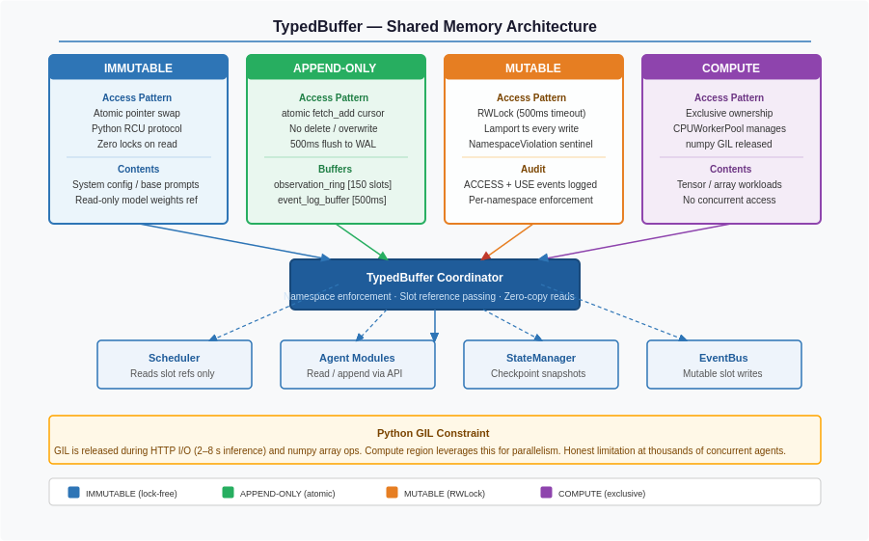
Figure 3: TypedBuffer — Four regions with protocols, slot contents, access patterns, and namespace enforcement

4. Shared Memory Bus, Kernel Hooks, Goal Resource Groups, and CapabilityBroker

4.1 Shared Memory Bus and Lamport Clock
The Bus is the single safe side-effect channel in the kernel. It owns the process-wide Lamport clock — a single AtomicCounter providing a monotonic timestamp to every event. On every bus.publish() call, the clock atomically increments ( ts = clock.fetch_add(1)) and returns the old value as that event's timestamp; the event is stamped, and a LamportEvent is returned to the caller, who may attach the timestamp to any records they write. When an external timestamp arrives from outside the process, a CAS loop updates the clock to max(clock, incoming_ts) + 1, maintaining the Lamport invariant across process boundaries and enabling global happened-before ordering even when multiple instances interact with shared SQLite storage. Every write to the MUTABLE_REGION records clock.load() as last_modified_lamport on the mutated slot — a free read with zero synchronization cost — so any two mutations anywhere in the system can be placed in deterministic happened-before order, making post-mortem reconstruction of state races tractable.
Subscriber dispatch is synchronous by design: all registered subscribers are called in the publisher's thread, in registration order. This gives causal ordering for free — every subscriber sees the same state with no race between them reading different versions of the world. Subscribers that need asynchronous handling queue internally; the Bus never queues on their behalf and does zero work of its own, so it cannot become a bottleneck. Hook callbacks are different: they are dispatched asynchronously through a dedicated thread pool of 2 to 3 threads with a 1ms timeout enforced per invocation. The publisher thread submits hook work to the pool and returns immediately — hook execution does not block the publisher and causal ordering between hook execution and subsequent Bus events is not guaranteed. This is the deliberate fix for Stall Path 3. A hook that exceeds the timeout is interrupted and deregistered, with a HOOK_DEREGISTERED event published carrying the violation details. The publisher thread is never blocked by hook behavior.
Hooks may publish to the Bus --- this is always permitted. Hooks may not call core subsystems directly. The Bus is the only channel where a subsystem can cause another to wake without knowing who is listening. It is explicit, safe, and auditable. The bus defines nine hook points that span the complete lifecycle of a goal: HOOK_GOAL_ARRIVED fires before Planner spawn, HOOK_SUB_GOAL_DISPATCHED fires before each agent spawn, HOOK_TRAJECTORY_PUBLISHED fires for every TrajectoryEntry publication, HOOK_RESOURCE_ASSIGNED and HOOK_RESOURCE_COMPLETED wrap every LLM dispatch, HOOK_ANOMALY_DETECTED carries EnvelopeMonitor signals, HOOK_AGENT_STALLED carries HealthPolicy soft or hard signals, HOOK_CHECKPOINT_WRITTEN acknowledges every checkpoint, and HOOK_DEREGISTERED signals that a hook was removed for violations. The Chronicler agent is implemented as a hook on HOOK_TRAJECTORY_PUBLISHED. The FleetMonitor is implemented as hooks on HOOK_RESOURCE_COMPLETED and HOOK_ANOMALY_DETECTED. Neither requires a separate thread, a polling loop, or any additional overhead.

Lamport Clock — Single Process-Wide AtomicCounter
On publish(): | ts = clock.fetch_add(1) ← atomic increment, returns old valueEvent stamped with tsSubscribers called synchronously in publisher's thread; hooks dispatched asynchronously via hook thread poolLamportEvent returned to caller
On receive_external(ts): | CAS loop: clock = max(clock, incoming_ts) + 1
TypedBuffer MUTABLE write: | clock.load() recorded as last_modified_lamport on mutated slotFree read — no increment, no synchronization costEnables deterministic happened-before ordering across any two mutations

Synchronous Dispatch — Causal Ordering
All subscribers called in publisher's thread | Registration order. No race between subscribers seeing different versions of state.
Subscriber needing async | Queues internally — the Bus never queues.
Bus overhead | Zero work. Cannot become a bottleneck.
Hooks → Bus | Always permitted. Hooks may NOT call core subsystems directly.

Hook Points — All Fired Through Bus
Hook Event | Fired When | Observer
HOOK_GOAL_ARRIVED | Before Planner spawn | —
HOOK_SUB_GOAL_DISPATCHED | Before each agent spawn | —
HOOK_TRAJECTORY_PUBLISHED | Every TrajectoryEntry publication | Chronicler
HOOK_RESOURCE_ASSIGNED | Every LLM dispatch | FleetMonitor
HOOK_RESOURCE_COMPLETED | Every LLM completion + actual cost | FleetMonitor
HOOK_ANOMALY_DETECTED | EnvelopeMonitor signals | FleetMonitor
HOOK_AGENT_STALLED | HealthPolicy SOFT or HARD recovery | —
HOOK_CHECKPOINT_WRITTEN | After every checkpoint write | —
HOOK_DEREGISTERED | Hook removed for violations | Developers
 | Zero polling. Zero separate threads. Zero additional overhead for Chronicler and FleetMonitor — they are hooks, not independent processes.

4.2 Kernel Hooks — Two-Tier Enforcement
Kernel Hooks provide the extensibility mechanism for the kernel without compromising its correctness guarantees. Hooks are registered by kernel developers, not by arbitrary user code — they are trusted extensions that expand kernel behavior within tight constraints. The trust boundary is enforced through two tiers of verification.
Tier 1 runs at load time. The hook's source is analyzed via AST to check its imports against a whitelist: typing, dataclasses, collections, math, statistics, nexus.kernel.types, and nexus.kernel.events. Any import outside this list — including indirect imports through helper modules — causes immediate rejection. This solves the transitive dependency problem directly: by preventing the import of my_utils entirely, any open() or network call inside it becomes unreachable, not just undetected. Slot access declarations are verified next: all declared read_slots must exist in the TypedBuffer schema; the write_slot, if declared, must be exactly one slot, present in the schema, and not in the IMMUTABLE_REGION. For SchedulingPolicy modules, three safety contract tests run at this stage — should_preempt(CRITICAL, EXECUTION) must return True, should_preempt(CRITICAL, BG) must return True, should_preempt(BG, CRITICAL) must return False. Any failure rejects the module with the specific failing test case named. On approval, the hook is registered via atomic pointer swap into the hook registry.
Tier 2 runs at runtime. Every hook invocation is wrapped with a tracemalloc snapshot and perf_counter_ns timing around execution — approximately 2 microseconds of overhead per call. Thresholds are 1ms elapsed and 1MB allocated. This tier is a soft cooperative bound, not a hard guarantee — Python cannot enforce hard per-callable memory limits. A hook that exceeds either threshold increments its violation counter; a clean run resets it to zero. Three consecutive violations trigger deregistration: HOOK_DEREGISTERED is published to the Bus with the hook_id, reason, and the last three elapsed and allocation samples attached. Developers receive the signal, fix the hook, and re-register.

Tier 1 — Load-Time Static Verification
Check | Rule | On Failure
Import whitelist | Hook may ONLY import from: typing, dataclasses, collections, math, statistics, nexus.kernel.types, nexus.kernel.events | REJECT at registration
read_slots | All declared read_slots must be in TypedBuffer schema | REJECT
write_slot | Max ONE write slot, must be in schema and NOT in IMMUTABLE_REGION | REJECT
SchedulingPolicy safety tests | should_preempt(CRITICAL, EXECUTION) == Trueshould_preempt(CRITICAL, BG) == Trueshould_preempt(BG, CRITICAL) == False | REJECT naming specific failing test
On approval | Atomic pointer swap into hook registry | —

Tier 2 — Runtime Monitoring Probe
Per-invocation wrapping | tracemalloc snapshot + perf_counter_ns around every hook execution. Overhead: ~2 microseconds.
Thresholds | >1ms elapsed OR >1MB allocated per invocation
Violation counter | Resets to 0 on clean run; increments on violation; 3 consecutive violations → DEREGISTER
HOOK_DEREGISTERED payload | { hook_id, reason, elapsed_samples[3], byte_samples[3] }
After deregistration | Developer receives signal; can fix and re-register
 | Python cannot enforce hard per-callable memory limits. The probe is a cooperative soft bound — effective against accidental violations, not malicious code. This is stated explicitly.

4.3 Goal Resource Groups and Token Debt Ledger
A GoalResourceGroup is created at goal arrival and destroyed at goal termination. It is the complete resource enforcement boundary for one goal. Hard limits are enforced at the point of the action they restrict — never discovered after violation. Five hard limits exist. token_budget: the LLMGateway rejects any dispatch where tokens_consumed + adjusted_estimate would exceed the budget, where adjusted_estimate = declared + debt_avg — conservative by design. wall_clock_deadline: the TokenManager refuses token re-acquisition after the deadline, preventing a goal from holding the surface past it. capability_namespace: the CapabilityBroker rejects any invocation of a capability outside the goal's registered frozenset at call time. memory_namespace: the TypedBuffer returns a NamespaceViolation sentinel on any slot access outside the goal's registered frozenset. max_concurrent_agents: the AgentFactory queues spawn requests when the limit is reached rather than spawning past it.
Soft limits never enforce directly — they fire Bus signals and leave the response to the loaded EnvelopePolicy module. token_soft_limit fires HOOK_ANOMALY_DETECTED with a BUDGET_WARNING signal. step_anomaly_mult fires HOOK_ANOMALY_DETECTED with a STEP_ANOMALY signal when step count exceeds N times the historical average. completion_floor at 0.3 fires HOOK_ANOMALY_DETECTED with a TERMINATE_CANDIDATE signal. The EnvelopePolicy receives all three and decides whether to CONTINUE, EXTEND, TERMINATE, or ESCALATE. Consumption tracking uses AtomicInts with no lock on increment. tokens_consumed is incremented at dispatch time, not on completion, to stay conservative. agents_active increments at spawn and decrements at termination. wall_clock_start is recorded at goal arrival.
The adjusted_estimate in the token budget check comes from the Per-Agent Token Debt Ledger, which lives in the TypedBuffer MUTABLE_REGION and maps each agent type to an AgentTokenDebt object tracking cumulative_debt (total tokens consumed above declared estimates lifetime), call_count (total calls made by this type), and avg_overrun (cumulative_debt / call_count). On call completion, overrun = max(0, actual - declared) is charged to the executing agent type. On dispatch, if call_count >= 10, the budget check uses declared + avg_overrun as the estimate; below ten calls, the declared estimate is used without inflation. Debt is attributed per agent type across all goals, never per goal. Contextualizer debt follows Contextualizer agents everywhere. A Chronicler that consistently runs within its declared estimate is never penalized for Contextualizer overruns. This cross-goal attribution is what makes the ledger useful — it tracks behavioral patterns of agent types, not incidental correlations within a single goal, and budget enforcement grows more accurate the more the system runs.

Hard Limits — Enforced at Construction
Limit | Enforcement Point | Behavior
token_budget | LLMGateway at dispatch time | Rejects if tokens_consumed + adjusted_estimate > budgetadjusted_estimate = declared + debt_avg (conservative by design)
wall_clock_deadline | TokenManager | Refuses token re-acquisition after deadline — goal cannot hold surface past it
capability_namespace | CapabilityBroker at call time | Rejects invocation if capability outside registered frozenset
memory_namespace | TypedBuffer at access time | Returns NamespaceViolation sentinel (see Sentinel section)
max_concurrent_agents | AgentFactory | Queues spawn requests at the limit — never over-spawns

Soft Limits — Bus Signals Only, Never Direct Enforcement
token_soft_limit | HOOK_ANOMALY_DETECTED: BUDGET_WARNING
step_anomaly_mult | HOOK_ANOMALY_DETECTED: STEP_ANOMALY when step_count > N × historical_avg
completion_floor = 0.3 | HOOK_ANOMALY_DETECTED: TERMINATE_CANDIDATE
EnvelopePolicy response | CONTINUE | EXTEND | TERMINATE | ESCALATE

Consumption Tracking — AtomicInts, No Lock
tokens_consumed | Incremented at DISPATCH time, not on completion (conservative by design)
agents_active | +1 at spawn, -1 at termination
wall_clock_start | Recorded at goal arrival

Per-Agent Token Debt Ledger — AgentTokenDebt Data Structure
cumulative_debt: int | Total tokens consumed above declared estimates, lifetime across all goals
call_count: int | Total LLM calls made by this agent type (used as warmup threshold)
avg_overrun: float | cumulative_debt / call_count — used as budget adjustment

On call completion | overrun = max(0, actual_tokens - declared_estimate)Charged to this agent_type. Never to next agent in same goal.
On dispatch (budget check) | if call_count >= 10: adjusted = declared + avg_overrun(agent_type)else: adjusted = declared (no inflation before warmup)
Result | Contextualizer debt follows Contextualizer agents across all goals.Chronicler accuracy is never penalized for Contextualizer behavior.Budget enforcement grows more accurate over time.

4.4 CapabilityBroker — The Serialization Seam
The CapabilityBroker is the only point in the entire system where serialization occurs. Inside the kernel, everything is native Python objects passed by reference. Outside the kernel, everything is msgpack bytes validated against an explicit schema. This single seam is the reason the system can claim zero-copy within the kernel while still supporting future cross-language agents.

The serialization format is msgpack with an explicit schema file that both the kernel and agents validate against. Pickle was rejected because deserializing a malicious pickle payload achieves code execution on the kernel side — an agent that sends a crafted TrajectoryEntry could compromise the kernel. JSON was rejected because it loses Python type information, is slower than binary formats, and provides no schema enforcement at the format level. Msgpack with a shared schema file provides safe deserialization, binary compactness, type preservation, and a format that any language speaking msgpack can participate in.

The broker also enforces capability_namespace at invocation time. If an agent attempts to invoke a capability outside its declared frozenset, the broker rejects the invocation at call time and logs the attempt to the SecurityKernel audit log. This is the fourth hard limit of the GoalResourceGroup, enforced at its specific enforcement point — not by checking permissions at goal creation and hoping for the best, but by rejecting the actual invocation in the moment.

This single-seam design provides three guarantees that are impossible in a multi-seam architecture: (1) complete audit capability — every capability invocation is logged; (2) complete confinement capability — every invocation is checked against the agent's manifest; (3) complete schema enforcement — every invocation is validated before dispatch and every result is validated before return.

Agent Space Kernel Space
───────── ────────────
agent.invoke(capability, args) CapabilityBroker
│ │
▼ msgpack serialize │
──────────────────────────────────────────►│
│ 1. Deserialize & validate schema
│ 2. Verify ProvenanceChain
│ 3. Check CapabilityConfinement
│ 4. Dispatch to Tool Factory script
│ 5. Validate output schema
│ 6. Log to AuditLog
◄──────────────────────────────────────────│
│ msgpack deserialize │
▼ │
result returned to agent
Fig 2.2 — CapabilityBroker intercept sequence — six steps on every invocation.

Serialization happens EXACTLY here. Nowhere else.

Kernel Side | TypedBuffer native Python objects. Zero-copy reads. GoalContract built from TypedBuffer slot references — no copies made inside kernel.
Broker | msgpack schema — both sides serialize against same schema file. Validates on serialize AND deserialize. Schema violation → REJECT at broker, not crash at agent.
Agent Side | Receives msgpack bytes, deserializes to hydrated GoalContract struct. Publishes TrajectoryEntry as msgpack.

Serialization Format Decision
Format | Decision | Reason
Pickle | REJECTED | Deserializing a malicious pickle payload executes arbitrary code on the kernel side. A compromised agent sending a crafted TrajectoryEntry could achieve kernel code execution.
JSON | REJECTED | Loses Python type information (datetime → str, etc.). Slower than binary. No schema enforcement at the format level.
msgpack + schema | CHOSEN | Safe deserialization — no arbitrary code execution. Binary compact format — faster than JSON. Schema file defines GoalContract and TrajectoryEntry. Both sides validate. Schema violation rejected at broker. Enables future cross-language agents (Rust, Go, etc.).

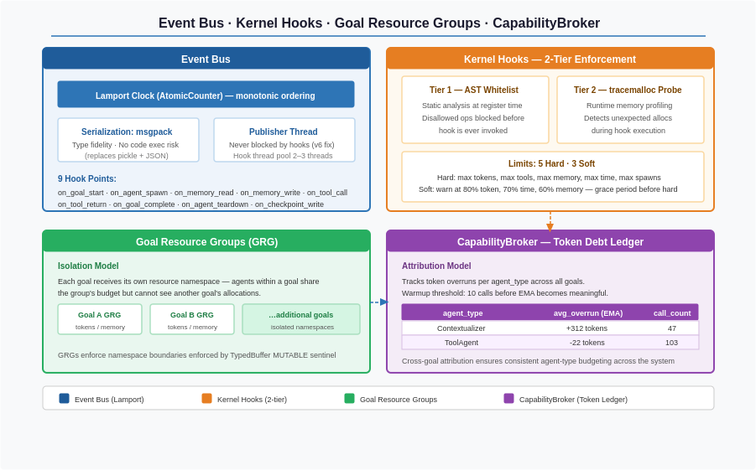
Figure 4: Shared Memory Bus, Kernel Hooks (two-tier enforcement), Goal Resource Groups with Token Debt Ledger, and CapabilityBroker serialization boundary

4.5 Rollback & Recovery Engine
The fundamental design principle here is that NEXUS already has almost everything the Rollback Engine needs — it’s just not wired together for the recovery direction. The AuditLog records every action. The ToolDescriptor already carries side_effect_class (READ, WRITE, DESTRUCTIVE, NETWORK). The Capability Broker touches every invocation. The missing piece is a pre-action state snapshot and a post-action consequence evaluator.
The engine lives at the intersection of three existing components: the CapabilityBroker (intercepts every action), the AuditLog (records what happened), and the Chronicler (reasons about consequences). What it adds is a fourth concern — reversibility tracking — which runs alongside these three rather than replacing them.

ActionLedger
The ActionLedger is the core new data structure. Before any DESTRUCTIVE or NETWORK or WRITE action executes, the CapabilityBroker doesn’t just log the invocation — it captures a pre-execution snapshot of the world state relevant to that action. For a filesystem_delete, this means: file path, file size, file hash, last-modified timestamp, and a copy of the file bytes written to a NEXUS-managed undo buffer in warm tier (or cold tier for large files). For a filesystem_write, it means: the previous contents of the file at that path. For an email send, it means: a full copy of the message with recipients, subject, body, and attachments. This snapshot is stored as an ActionLedgerEntry keyed by (goal_id, sub_goal_id, action_sequence_number) with a TTL — undo buffer entries expire after a configurable window (default 24 hours for filesystem, 1 hour for network actions) because indefinitely storing pre-action state is impractical.

ReversibilityClassifier
The ReversibilityClassifier runs at action intercept time before the undo snapshot is taken. It reads the ToolDescriptor’s side_effect_class and the action arguments to produce one of four classifications: FULLY_REVERSIBLE (local filesystem operations where a byte-perfect restore is possible), PARTIALLY_REVERSIBLE (operations where the world-state change can be undone but side-effects cannot — Slack message delete, meeting cancellation), COMPENSATABLE (irreversible primary action but a compensating action exists — email correction, follow-up message), and IRREVERSIBLE (no mechanical recovery path exists — government form submission, financial wire). This classification is not heuristic — it comes from a static classification table keyed on (capability_name, argument_pattern). The IRREVERSIBLE class is the only one that currently routes to SafeModeGate. With this engine, PARTIALLY_REVERSIBLE and COMPENSATABLE also get structured handling, not just prevention.
The PostconditionEvaluator is what triggers rollback. After a sub-goal completes and the Kernel verifies postconditions, a failure doesn't just mean "log it and learn." The PostconditionEvaluator asks: which specific actions in this sub-goal's ActionLedger contributed to the postcondition failure? It does this by replaying the ActionLedger entries chronologically and finding the last point at which postconditions were still satisfiable. Everything after that point becomes the rollback candidate set.
The CompensationPlanner then takes the rollback candidate set and produces one of three outcomes. For FULLY_REVERSIBLE entries: execute the undo operation automatically (restore the file, revert the write) and publish a ROLLBACK_COMPLETED event to the bus. For PARTIALLY_REVERSIBLE and COMPENSATABLE entries: generate a structured compensation proposal containing what happened, what the mechanical compensation would be, and what the residual irreversible side-effects are — then route this to CallUser() with this structured context rather than a generic "something went wrong." For IRREVERSIBLE entries: CallUser() with full context and the explicit acknowledgment that no mechanical recovery exists.
The key architectural decision is where the ActionLedger lives in the storage hierarchy. Pre-action snapshots for filesystem operations go to warm tier (SQLite BLOB storage) for fast retrieval during the recovery window. Large file pre-action copies go to cold tier under a rollback/ directory with the same TTL enforcement. The ActionLedger index (metadata without byte contents) is hot tier — the CapabilityBroker reads it on every DESTRUCTIVE action to check whether a valid undo entry exists before attempting recovery.
One critical invariant: the Rollback Engine never automatically executes compensating actions that have their own DESTRUCTIVE or NETWORK side effects without human approval. Auto-rollback is only permitted for local, byte-perfect, fully reversible operations. Anything that touches the world beyond the local filesystem requires human confirmation via the structured CallUser() proposal.

4.6 Argument-Level Permission Scoping
The current CapabilityConfinement is a frozenset of capability names. It answers “can this agent call filesystem_read?” but not “can this agent call filesystem_read on /home/user/finance/?” The fix requires two additions: ArgumentScopeManifest and a ScopeEnforcer that runs inside the CapabilityBroker between steps 3 (schema validation) and 4 (tool dispatch) in the existing dispatch sequence.

ArgumentScopeManifest and ScopeEnforcer
The ArgumentScopeManifest extends the per-agent manifest from a frozenset of capability names to a mapping from capability name to a scope constraint. Scope constraints are expressed as predicates on the arguments of that capability. For filesystem capabilities, the predicate is a set of allowed path prefixes or glob patterns. For communication capabilities (email, Slack), the predicate is a set of allowed recipients, channels, or domains. For API capabilities, the predicate is a set of allowed endpoints and HTTP methods. For shell capabilities, the predicate is a set of allowed command patterns with explicit argument whitelisting.
The manifest for a FileSystem specialist scoped to a specific project would read: filesystem_read is allowed where path starts with /home/user/projects/q3_report/ or /tmp/nexus_workspace/. filesystem_write is allowed where path starts with /tmp/nexus_workspace/. filesystem_delete is never allowed (empty scope). This is structurally different from the current capability name check — it's a predicate evaluated against actual runtime arguments.
The ScopeEnforcer runs the predicate evaluation at dispatch time. For simple path prefix checks this is O(1) string comparison — faster than the schema validation already running. For more complex predicates (glob patterns, regex on arguments) it's still deterministic, still no LLM, still sub-millisecond. The ScopeEnforcer produces one of three outcomes: PERMITTED (predicate satisfied, proceed to dispatch), SCOPE_VIOLATION (predicate failed, log and block like a capability confinement violation), or SCOPE_AMBIGUOUS (the predicate cannot be evaluated because the argument is a variable resolved at runtime, for example a path constructed from a previous tool result). The SCOPE_AMBIGUOUS case is the interesting one — it routes to a lightweight scope resolution check where the Kernel evaluates whether the dynamically constructed argument, when resolved, falls within the declared scope.
Scope Inheritance is the mechanism by which scopes are assigned. The Agent Factory doesn't hardcode every scope — that would make the manifest enormous and unmaintainable. Instead, scopes are inherited from the GoalContract's execution context. When the Contextualizer assembles the GoalContract for a FileSystem sub-goal, it includes a declared_workspace field derived from the goal's stated input and output paths. The Agent Factory reads this field at spawn time and derives the ArgumentScopeManifest from it: the agent is scoped to the declared workspace paths plus the NEXUS system temp directory. Agents working on broader goals (system-wide search) can declare a broader workspace, but that declaration must be present in the GoalContract and traceable back through the ProvenanceChain to the original user intent. A broad scope requires broad user intent — you can't spawn a FileSystem agent scoped to the entire filesystem unless the user's original goal is itself that broad.
Scope Escalation is the formal mechanism for when an agent discovers mid-task that it needs to access something outside its current scope. Rather than failing silently or violating the constraint, the agent emits a ScopeEscalationRequest capability invocation — which is always in every agent's manifest. The request contains the current scope, the requested expanded scope, and the justification derived from the task context. This routes to the human via the existing CallUser() mechanism with a structured proposal: "I found that the file you asked me to process links to another file outside my current workspace. Do you want me to extend my access to include that path?" The human's approval is logged in the ProvenanceChain and becomes part of the immutable audit trail.
This also solves the cross-agent scope bleed problem. Currently if a Planner creates a FileSystem sub-goal and a ShellExecutor sub-goal in the same goal decomposition, both could theoretically access overlapping paths. With argument-level scoping, each sub-goal’s agent gets a scope derived from its specific declared workspace in the GoalContract — even if both agents have filesystem_read in their capability manifests, their argument scope predicates are different and non-overlapping by construction.

5. GoalDependencyGraph, Agent Lifecycle, and Versioned Checkpoints

5.1 GoalDependencyGraph — Structure and Operational Model
The GoalDependencyGraph is the data structure that encodes how a goal is broken into sub-goals and what depends on what. It lives in the TypedBuffer MUTABLE_REGION under goal_states, keyed by goal_id. The Planner produces it; the Graph Subsystem stores it and manages its entire lifecycle. The graph contains a goal_id, a sub_goals map from sg_id to SubGoalNode, a first_subgoal_type set by the Planner at graph publication, a parallel_state map used for checkpoint recovery, and a last_modified_lamport timestamp.
Each SubGoalNode contains: agent_type from the Planner's annotation, depends_on listing the sub-goal IDs that must complete before this one can start, status cycling through PENDING → CONTEXT_READY → RUNNING → COMPLETE → FAILED, result populated with the TrajectoryEntry payload on completion, contract_ref as a TypedBuffer slot reference to the assembled GoalContract, and critical_path_len — the number of steps to goal completion from this node, annotated by the Planner and used as a tiebreaker within Level 2 scheduling: among agents at the same virtual inference time, the one on the longest critical path dispatches first.
Every graph must have sg_0 as a ProcessOrchestratorAgent node with an empty depends_on list. The Graph Subsystem validates this at graph receipt — no sg_0, wrong agent type on sg_0, or any dependencies on sg_0 all cause immediate rejection with a GOAL_INVALID signal to the Bus. The ProcessOrchestratorAgent is the mandatory first step for every goal: it verifies the target application is running, the window is accessible and focused, and permissions are available — launching the application if needed within the capability_namespace. It makes no LLM call, performing pure OS interaction and verification, completing in milliseconds to low seconds. All UI-TARS sub-goals depend on sg_0 either directly or transitively. No execution agent ever runs against an unverified environment.
ENFORCEMENT RULE: If any sub-goal in the decomposition has agent_type=UITAR, exactly one sg must be ProcessOrchestrator with depends_on=[]. The GoalAlgebraValidator catches violations at microsecond-scale schema validation, before any execution begins.

The canonical shape looks like this: sg_0 (ProcessOrchestrator, no dependencies) branches to sg_1 (ExportPDF, depends on sg_0) and sg_2 (ComposeEmail, depends on sg_0) running in parallel, with sg_3 (AttachAndSend, depends on both sg_1 and sg_2) waiting until both complete. The graph makes the execution order explicit and machine-enforceable — not a convention, not a guideline.
GoalDependencyGraph example — 'Export LibreOffice spreadsheet to PDF and email it'

sg_0: ProcessOrchestrator ─── depends_on: [] (mandatory first sub-goal)
'Ensure LibreOffice Calc is running with target file'
│
▼ completes → publishes TrajectoryEntry
sg_1: UITARSAgent ─── depends_on: [sg_0]
'Export file to PDF via File→Export As→Export as PDF'
│
▼ completes → publishes TrajectoryEntry
sg_2: UITARSAgent ─── depends_on: [sg_1]
'Open Thunderbird and compose email with PDF attachment'
│
▼ completes → publishes TrajectoryEntry
sg_3: UITARSAgent ─── depends_on: [sg_2]
'Address email, add subject line, send'

Kernel scan on each TrajectoryEntry publication: O(N) — N=4 here.
For each node: if all depends_on completed → dispatch.
Fig 3.3 — GoalDependencyGraph example with ProcessOrchestrator as mandatory sg_0.

GoalDependencyGraph Data Structure
Field | Type | Description
goal_id | string | Identifies which goal this graph belongs to
sub_goals | dict[sg_id → SubGoalNode] | All sub-goals with their type, deps, status, result, contract_ref
first_subgoal_type | string | Set by the Planner when the full graph is published
parallel_state | dict | For checkpoint recovery of parallel execution
last_modified_lamport | int | Lamport timestamp of last mutation

SubGoalNode Data Structure
Field | Values / Type | Description
agent_type | string | From Planner annotation — maps to AgentModule Registry
depends_on | [sg_id] | Dependency list — all must be COMPLETE before this node can run
status | PENDING | CONTEXT_READY | RUNNING | COMPLETE | FAILED | Current state of this sub-goal node
result | payload | None | Published TrajectoryEntry data — stored after COMPLETE
contract_ref | slot_ref | None | TypedBuffer slot reference to GoalContract
critical_path_len | int | Steps to goal completion from this node — used as Level 2 tiebreaker

Mandatory Graph Constraint — ProcessOrchestrator as sg_0
Validation at graph receipt | No sg_0 → signal GOAL_INVALID to Bussg_0.agent_type != ProcessOrchestratorAgent → rejectsg_0.depends_on != [] → reject (sg_0 must have zero dependencies)
ProcessOrchestratorAgent job | Verify target app is running. Verify window is accessible and focused. Verify permissions. Launch app if not running (within capability_namespace). Publish verified environment facts as result. NO LLM call — pure OS interaction. Completes in milliseconds to low seconds.
Guarantee | All UI-TARS sub-goals depend on sg_0 either directly or transitively. No execution agent ever runs against an unverified environment.

Canonical Graph Shape — Example
sg_0: ProcessOrchestrator | depends_on: [] | No LLM call | Must complete before any UI-TARS sub-goal
↓ (blocks on sg_0) | sg_1: Export PDF | ↓ (blocks on sg_0) | sg_2: Compose Email
sg_1 and sg_2 run in PARALLEL after sg_0 — independent sub-goals
↓ (blocks on BOTH sg_1 AND sg_2)
sg_3: Attach and Send

5.2 The Unblocking Protocol and Result Passing
GoalDependencyGraph — Unblocking Protocol and Graph-Lookahead.
On every TrajectoryEntry publication, the Graph Subsystem executes the unblocking check in exact sequence. Step 1: write sg_N.status to COMPLETE, store the result payload, record last_modified_lamport. Step 2: O(N) scan over all PENDING nodes — a node becomes executable when every entry in its depends_on list has status COMPLETE. Step 3: collect dependency results for each newly executable node as TypedBuffer slot references — zero copy, no serialization inside the kernel. Step 4: spawn a Contextualizer for each newly executable node, passing the sub-goal specification and the collected dependency results; the Contextualizer performs retrieval and synthesis, writes the GoalContract to a TypedBuffer slot, sets contract_ref and transitions status to CONTEXT_READY. Step 5: call the Scheduler directly for reactivation, dispatching by Level 1 priority then Level 2 with critical_path_len as tiebreaker. Step 6: graph-lookahead — identify nodes that would become executable if each newly executable node succeeds, and spawn speculative Contextualizers for them immediately.
Result passing is what makes dependency resolution meaningful. When the Contextualizer assembles the GoalContract for sg_3 (AttachAndSend), it receives sg_1's result containing the exact verified file path and file size, and sg_2's result containing confirmation that the compose window is open, the recipient is set, and the window ID to target. These are not retrieved approximations — they are verified facts produced by actual execution of prior sub-goals. The synthesis LLM call for sg_3 references them with full confidence: no hallucination risk on the file path, no assumption about the compose window state.
Graph-lookahead eliminates the wait between a sub-goal completing and the next one having its context ready. When sg_0 starts execution, Contextualizers for sg_1 and sg_2 are spawned immediately and in parallel. They perform all retrieval work — BM25 strategy file search, vector search, capability matrix lookup, WorldModel snapshot read — then pause waiting on sg_0's result slot. The moment sg_0 completes and its result is written, both Contextualizers proceed to their synthesis calls. By the time the execution agents for sg_1 and sg_2 are dispatched, their GoalContracts are already assembled — zero additional wait. When sg_1 and sg_2 run in parallel, sg_3's Contextualizer is spawned when the second of the two completes, at which point both results are available for synthesis. If a predecessor fails while a speculative Contextualizer is running, the GoalResourceGroup signals abort and it terminates immediately. The miss cost is the retrieval work already done — approximately 5ms — with no synthesis call wasted. Against the seconds-scale execution time of the agents themselves, this is negligible.

O(N) Unblocking Protocol — Exact Step Sequence
Step | Action | Notes
1 | Write sg_N.status = COMPLETE, sg_N.result = payload, record last_modified_lamport | Atomic write with Lamport timestamp
2 | O(N) scan: for each PENDING node P, check all deps_complete = all(dep.status == COMPLETE) | Linear scan — no shortcuts
3 | Collect dependency_results for each newly executable P as TypedBuffer slot refs | Zero copy inside kernel
4 | Spawn Contextualizer for each newly executable P with sub_goal + dependency_results | Contextualizer does retrieval + synthesis + writes GoalContract to slot, sets contract_ref and status = CONTEXT_READY
5 | Graph calls Scheduler directly: reactivate(P) for each CONTEXT_READY node | Dispatch by Level 1 priority then Level 2 with critical_path_len as tiebreaker
6 | Graph-lookahead for N+1: spawn speculative Contextualizers for nodes that would become executable if P succeeds | Speculative Ctx waits on result slot before synthesis call. On failure: GoalResourceGroup signals abort.

5.3 Agent Lifecycle — Spawn to Termination
When a goal arrives, a GoalResourceGroup is created with all hard limits registered — memory_namespace, capability_namespace, token budget, wall clock deadline, and max concurrent agents. HOOK_GOAL_ARRIVED fires synchronously. The Kernel then spawns exactly one thing unconditionally: the Planner. This is the only hardcoded spawn decision in the entire kernel. Everything else is driven by graph structure.
The Planner produces an annotated GoalDependencyGraph mapping each sub_goal_id to a SubGoalNode containing agent_type, depends_on list, initial PENDING status, null result, null contract_ref, and critical_path_len. The Planner annotates agent types and dependency relationships — it never decides execution strategy. The Graph Subsystem stores the graph in the TypedBuffer MUTABLE_REGION. The Scheduler identifies initially dispatchable nodes — those with all dependencies met — and dispatches them immediately.
Agent module lookup uses the AgentModule Registry, mapping agent_type strings to AgentModule objects. Each AgentModule declares: agent_type as a unique identifier, interface_version for compatibility checking at load time, priority_class as EXECUTION, BG, or PLANNING, tool_manifest enforced by the CapabilityBroker, memory_read_scope and memory_write_scope specifying allowed TypedBuffer slots (maximum one write slot), and an entry_point function from GoalContract to TrajectoryEntry. There is no spawn_condition callable — the kernel never runs module-provided callables to make its own dispatch decisions. The Planner annotates; the kernel dispatches mechanically. Runtime registration allows the Demonstrator to register new agent types via atomic pointer swap into the registry without a restart.
During execution, agents emit heartbeats to agent_registry in the MUTABLE_REGION. Foreground agents acquire the Input Surface Token via atomic CAS with no lock, releasing it immediately on yield. LLM calls are dispatched through the LLMGateway to the ResourceScheduler.
On completion, the agent publishes its TrajectoryEntry to the Bus. HOOK_TRAJECTORY_PUBLISHED fires and the Chronicler hook receives it via the hook thread pool (asynchronous — causal ordering with subsequent Bus events not guaranteed, acceptable for an observational hook). The Graph Subsystem performs the O(N) unblocking check, reactivates newly satisfiable agents, spawns Contextualizers for next dispatchable sub-goals, and decrements agents_active.
The Agent Health Watchdog runs as a dedicated thread inside the kernel process, polling agent_registry every 5 seconds. An agent whose heartbeat age exceeds 60 seconds at status RUNNING is considered stalled. Soft recovery fires first: a wake signal is injected into the agent thread and the watchdog waits one polling interval. If the heartbeat recovers, the event is logged and monitoring continues. If not, hard recovery fires: the thread is terminated, the last checkpoint is loaded from warm-tier SQLite with the migration chain running if the format version has changed, and the agent is respawned from checkpoint.sub_goal_index. Recovery cost is proportional only to the distance from the last checkpoint — not the total goal complexity.

Goal Arrival Sequence
1. GoalResourceGroup created | All hard limits registered. memory_namespace and capability_namespace registered.
2. HOOK_GOAL_ARRIVED fires | Synchronously. All hook observers notified before any agent spawns.
3. Kernel spawns the Planner | The ONLY hardcoded spawn decision in the entire kernel.
4. Planner produces graph | Annotated GoalDependencyGraph: { sub_goal_id → SubGoalNode }. Planner never decides execution strategy — only annotates agent_type + deps.
5. Graph stored | In TypedBuffer MUTABLE_REGION with last_modified_lamport recorded.
6. Scheduler dispatches | Identifies nodes with all dependencies met → immediately dispatchable.

AgentModule Data Structure
Field | Type | Description
agent_type | string | Unique identifier — used for module registry lookup
interface_version | string | Compatibility check at load time
priority_class | EXECUTION | BG | PLANNING | Determines scheduler queue level
tool_manifest | [] | Enforced by CapabilityBroker — agent cannot invoke outside this list
memory_read_scope | [slot_id] | TypedBuffer slots this agent is allowed to read
memory_write_scope | [slot_id] (max 1) | TypedBuffer slot this agent may write — maximum one
entry_point | fn(GoalContract) → TrajectoryEntry | Agent execution function
spawn_condition | ELIMINATED | Kernel never runs module callables for its own dispatch decisions

Execution — Running Agent
Heartbeat | Emitted periodically to agent_registry in MUTABLE_REGION. Agent Health Watchdog polls every 5s.
Input Surface Token | Foreground agents acquire via atomic CAS — no lock. Released immediately on yield.
LLM calls | Dispatched through LLMGateway → ResourceScheduler. Debt ledger consulted for adjusted estimate first.

Agent Completion
TrajectoryEntry published | Agent publishes result to Bus.
HOOK_TRAJECTORY_PUBLISHED | Fires. Chronicler hook receives it via hook thread pool (asynchronous).
Graph O(N) unblocking check | Newly satisfiable agents identified and reactivated.
agents_active decremented | AtomicInt — no lock.

Agent Health Watchdog Recovery Protocol
Poll interval | Every 5 seconds — dedicated thread inside kernel process
Stall threshold | heartbeat_age > 60s AND status == RUNNING
SOFT recovery | Wake signal injected into agent thread. Wait one 5s interval.
HARD recovery (if still stalled) | Terminate thread. Load last checkpoint from SQLite warm tier (run migration chain if version mismatch). Respawn from checkpoint.sub_goal_index.
Recovery cost | Proportional to distance from last checkpoint only — not total goal complexity.

5.4 Versioned Checkpoint System
Every checkpoint contains: format_version (read first, before any other field — enforced by the load protocol, not convention), kernel_version identifying which kernel binary wrote it, goal_id, written_at as a Lamport timestamp from Bus.publish(), written_at_wall as a wall clock timestamp for human debugging only, sub_goal_index indicating the DAG node to resume from, session_variables as a schema-validated map, agent_state_refs as TypedBuffer slot references rather than copies, and an integrity SHA-256 hash over all above fields.
The load protocol never blindly rejects an old checkpoint — it migrates it forward. A checkpoint missing format_version is rejected immediately with an explicit log entry; the goal restarts from scratch, surfaced to the user. A checkpoint with format_version present enters the migration chain: a while loop that runs as long as the current version does not equal CURRENT_FORMAT. Each iteration looks up the migration function for the current version in MIGRATION_REGISTRY. If no function exists for that version, the checkpoint is rejected with a log entry naming the missing migration path. If the function exists, it is called as a pure function — takes the old dict, returns a new dict, no side effects — and CHECKPOINT_MIGRATED is logged with the from and to versions. The loop continues until CURRENT_FORMAT is reached.
Integrity verification runs after the full migration chain completes, never before. Verifying before migration would fail every old-format checkpoint — the hash was computed over the old fields. Verifying after migration catches corruption that occurred either during storage or during migration function execution. A hash mismatch rejects with an integrity failure log. A match returns the hydrated Checkpoint object to the RecoveryModule.
The Migration Registry currently chains nexus-3.0.0 → nexus-3.1.0 via migrate_300_to_310() and nexus-3.1.0 → nexus-3.2.0 via migrate_310_to_320(). A checkpoint written by a 3.0.0 kernel and loaded by a 3.2.0 kernel runs both migrations automatically. Adding a new version requires bumping CURRENT_FORMAT, writing the pure migration function from the previous version, and registering it. Old versions remain readable until explicitly removed.

Checkpoint Structure
Field | Type / Source | Description
format_version | string — e.g. "nexus-3.2.0" | READ FIRST before all other fields. Absence = reject immediately.
kernel_version | string — e.g. "nexus-3.2.1" | Which kernel binary wrote this checkpoint.
goal_id | string | Identifies the goal being checkpointed.
written_at | Lamport timestamp | From Bus.publish() return value — causal ordering.
written_at_wall | wall clock timestamp | Human debugging only — not used for ordering.
sub_goal_index | int | DAG node to resume from on restart.
session_variables | dict[str → any] | Schema-validated at write time.
agent_state_refs | [slot_ref] | TypedBuffer slot references, not copies.
integrity | SHA-256 | Hash of all above fields. Verified AFTER full migration chain.

Load Protocol — Migration Chain
format_version absent | REJECT. Log: "CHECKPOINT_REJECTED: no format_version field". Goal restarts.
format_version present | Enter migration loop: while version != CURRENT_FORMAT, look up migration function in MIGRATION_REGISTRY.
Migration function missing | REJECT. Log: "no migration path from {version}". Goal restarts.
Migration function found | Call as pure function: old_dict → new_dict (no side effects). Log CHECKPOINT_MIGRATED: {from} → {to}. Continue loop.
After full migration chain | Verify integrity SHA-256. Mismatch → REJECT "integrity failure post-migration". Match → return hydrated Checkpoint object.

Migration Registry — Current State
nexus-3.0.0 → nexus-3.1.0 | migrate_300_to_310()
nexus-3.1.0 → nexus-3.2.0 | migrate_310_to_320() ← CURRENT
Multi-hop example | A 3.0.0 checkpoint on 3.2.0 kernel: runs both migrations automatically.
Adding a new version | 1. Bump CURRENT_FORMAT2. Write pure migration fn from previous version3. Add to MIGRATION_REGISTRYOld versions remain readable until explicitly removed.
 | Migration functions are pure: old dict in, new dict out, no side effects. Must update format_version field. Must preserve or transform all semantic fields. Schema validation runs on output before integrity check.

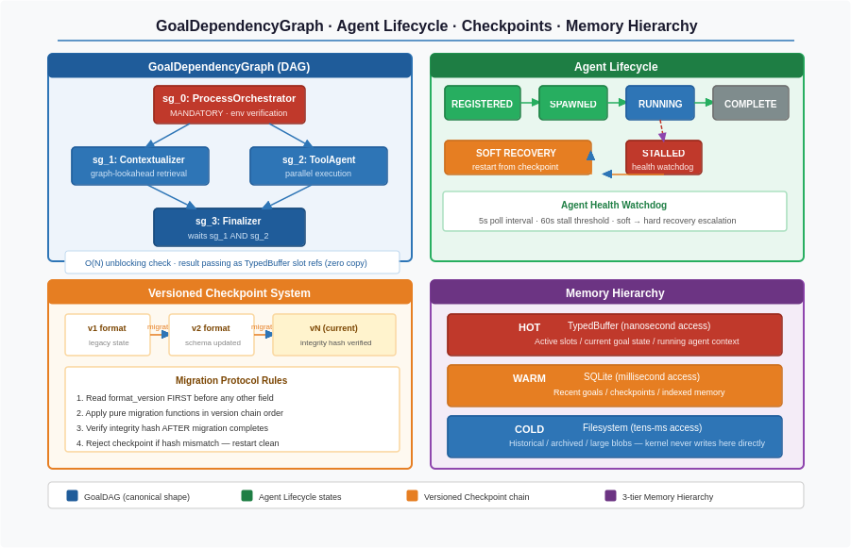
Figure 5: GoalDependencyGraph with canonical shape and unblocking protocol, Agent Lifecycle, Versioned Checkpoint System, and Memory Hierarchy

6. Watchdog Architecture, Thread Model, and End-to-End Data Flow

6.1 The Three Stall Paths
The kernel's DAG call graph eliminates deadlocks caused by circular dependencies between subsystems. Three stall paths remain that have nothing to do with the call graph and everything to do with physical blocking inside individual threads.
Stall Path 1 — RWLock on the MUTABLE_REGION. An agent thread that acquires a read lock and then stalls — through an infinite loop, OS suspension, or an I/O operation it should not be performing — prevents the kernel thread from acquiring the write lock. The call graph has no cycles; the kernel is still frozen. RWLock write acquisition therefore uses try_acquire_write(timeout=500ms) instead of blocking forever. On timeout, a LOCK_TIMEOUT event is published to the Bus with the slot identifier and holder_agent_id. The EnvelopeMonitor sees the event and signals the Agent Health Watchdog to identify and recover the stalled agent. The kernel retries write lock acquisition after recovery. An infinite block becomes a recoverable timeout.
Stall Path 2 — CPUWorkerPool blocking the main thread. If StateManager dispatches WorldModel snapshot construction to the CPUWorkerPool and waits synchronously for the result, any worker process that is OOM-killed, encounters a hardware fault in a numpy operation, or has a bug in snapshot construction causes StateManager.wait() to never return — the main kernel thread is frozen on an external process it cannot control. StateManager therefore dispatches to the CPUWorkerPool queue non-blocking and returns immediately to the event loop. The CPUWorkerPool completes snapshot construction on its own threads and publishes WORLD_MODEL_READY to the Bus. StateManager is subscribed to WORLD_MODEL_READY and performs the atomic pointer swap on event receipt. The main kernel thread never blocks on any external process.
Stall Path 3 — Hook callbacks blocking the publisher thread. A hook with a blocking I/O call that slips past Tier 1 static verification freezes the publisher thread inside Bus.publish() — since the publisher thread is a kernel subsystem thread, the kernel is frozen. Bus.publish() therefore submits hook invocations to a dedicated hook thread pool of 2 to 3 threads and returns immediately. Each invocation runs in the pool with a 1ms timeout enforced by a pool watchdog timer. A hook exceeding the timeout is interrupted and deregistered, with HOOK_DEREGISTERED published from the watchdog timer. The acknowledged tradeoff is that hook execution is now asynchronous — causal ordering between hook execution and subsequent Bus events is no longer guaranteed. For observational hooks like Chronicler and FleetMonitor this is acceptable; for hooks that write TypedBuffer slots, the write reaches the slot and the kernel reads it on the next scheduling decision — one scheduling cycle delay, architecturally acceptable. The publisher thread is never frozen by hook behavior.

6.3 The Watchdog Architecture — Three Monitors, Three Scopes.
The Agent Health Watchdog, the Kernel Health Watchdog, and the Envelope Monitor each watch exactly what they can reliably observe. No monitor watches something it could not survive the failure of.
Agent Health Watchdog — inside the kernel process, watches agents. Runs as a dedicated thread inside the kernel process, polling agent_registry every 5 seconds. Detects individual agent threads whose heartbeat age exceeds 60 seconds at status RUNNING. Responds with soft recovery first — a wake signal injected into the agent thread, one polling interval to recover — then hard recovery if the heartbeat does not resume: thread terminated, last checkpoint loaded from SQLite with migration chain if needed, agent respawned from checkpoint.sub_goal_index. It can do this because individual agent threads can stall without freezing the kernel process. It cannot watch the kernel thread itself — if the kernel process freezes, the Python GIL held by the frozen main thread prevents this in-process thread from running.

The Agent Health Watchdog thread inside the kernel process cannot watch the kernel thread itself. If the kernel process stalls and the Python GIL is held by the frozen main thread, the in-process watchdog cannot run. The Kernel Health Watchdog therefore runs as a completely separate OS process.

Kernel Health Watchdog — separate OS process, watches the kernel. Runs as a completely separate OS process with its own PID, its own GIL, and its own address space. Immune to kernel process stall by construction. The mechanism is a single atomic timestamp in an OS-level shared memory segment. The main kernel thread writes the current wall clock timestamp to this segment every 1 second — a single atomic write, immune to GIL contention. If the main thread stalls on any of the three stall paths, it stops writing and the timestamp grows stale. The Watchdog reads it every 1 second; if the age exceeds 3 seconds, the recovery sequence begins. Step 1: SIGTERM sent to the kernel process — the kernel's SIGTERM handler flushes the event log buffer and writes checkpoints for all active goals, given 5 seconds to complete. Step 2: if the process is still alive after 5 seconds, SIGKILL is sent. Step 3: the Watchdog reads the last checkpoint from warm-tier SQLite, runs the migration chain if the format version has changed, and verifies integrity. Step 4: a new kernel process is spawned with the checkpoint as startup parameter; in-flight goals resume from checkpoint.sub_goal_index. Step 5: the Watchdog begins monitoring the new process heartbeat. It does not monitor agents, make LLM calls, touch the TypedBuffer, or participate in scheduling or goal execution. One job: detect kernel silence, restart kernel.
Envelope Monitor — inside the kernel process, watches goal progress. Runs on a 200ms timer, performing pure arithmetic on hot-tier values — no I/O, no LLM calls, microseconds per evaluation. Watches token consumption, step count, wall clock elapsed, and completion probability EMA against the GoalResourceGroup's registered limits. Detects budget anomalies and publishes signals to the Bus — BUDGET_WARNING, STEP_ANOMALY, TERMINATE_CANDIDATE — leaving all response decisions to the loaded EnvelopePolicy module. It never enforces directly.

Clean Separation of Concerns
Monitor | Location | Watches | Can Watch Because
Agent Health Watchdog | Inside kernel process (thread) | Individual agent threads(heartbeat > 60s) | Alive when agents stall; agents stall independently of kernel thread
Kernel Health Watchdog | Separate OS process (PID B) | Entire kernel process(heartbeat > 3s via shared memory) | Separate address space, separate GIL — immune to kernel process stall
Envelope Monitor | Inside kernel process (thread) | Goal progress, budget, completion probability | Runs on timer; signals Bus only — never acts directly

6.5 End-to-End Data Flow — One Complete Goal
The complete path for a single goal through the Cognitive Kernel illustrates how every component described in this document works together. At T=0, a goal arrives. The kernel creates a GoalResourceGroup with all hard limits registered, establishes the memory and capability namespaces, fires HOOK_GOAL_ARRIVED synchronously, and spawns the Planner — the only hardcoded spawn decision in the entire kernel. The Planner publishes the complete GoalDependencyGraph in one batch. The Scheduler immediately identifies all nodes with no dependencies — sg_0 in the canonical case — and dispatches their Contextualizers.

At T=1, the Planner publishes the complete GoalDependencyGraph in one batch. The Scheduler immediately identifies sg_0 as the only node with no dependencies and dispatches its Contextualizer. By T=3, the Contextualizer has completed the GoalContract for sg_0 and the ProcessOrchestratorAgent is dispatched. Simultaneously, graph-lookahead spawns speculative Contextualizers for sg_1 and sg_2, which begin their retrieval work immediately. At T=4, sg_0 completes with verified environment facts. The O(N) unblocking check identifies sg_1 and sg_2 as executable. The speculative Contextualizers receive sg_0's result and proceed to their synthesis calls. By T=6, GoalContracts for both sg_1 and sg_2 are ready. Both are dispatched in parallel through the CapabilityBroker, serialized to msgpack at that boundary, deserialized on the agent side. At T=11 and T=13 respectively, sg_2 and sg_1 complete. The O(N) check unblocks sg_3. Ctx-sg_3 is spawned with both results as TypedBuffer slot references. At T=15, the GoalContract for sg_3 is ready containing the exact file path from sg_1 and the window state from sg_2. At T=20, sg_3 completes. The GoalResourceGroup is destroyed, namespaces are deregistered, and the goal is complete. Total elapsed time: 20 seconds versus 26 seconds sequential without parallelism and lookahead.

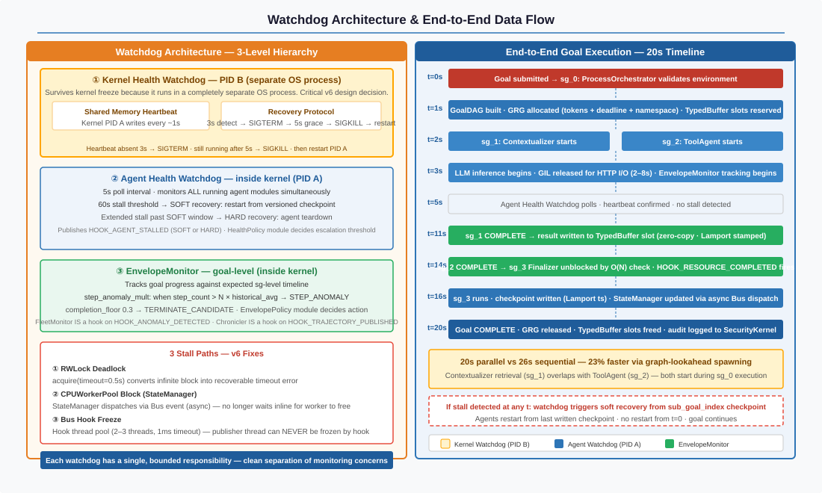
Figure 6: Watchdog Architecture (PID separation, stall paths, design fixes, recovery sequence) and complete end-to-end data flow for one goal

7. Six Architectural Principles — Enforcement Points

The six principles of the NEXUS Cognitive Kernel are not aspirational statements. Each principle has a specific enforcement point in the architecture — a place in the code where the principle is implemented mechanically and cannot be violated through carelessness or configuration.

Principle 1: Mechanism is monolithic, policy is modular. The line between them is a versioned interface with verification. Enforcement point: PolicyDispatcher load-time verification. Version check plus safety contract tests run before atomic pointer swap. A module that fails any test cannot be loaded. A module that passes is swapped in atomically with no kernel restart required.

Principle 2: Isolation by data structure, not process boundary. IPC overhead is unacceptable at this scale. Enforcement point: TypedBuffer region protocols enforce access patterns, namespace enforcement at slot access enforces goal isolation, and CapabilityBroker manifest checks enforce tool boundaries. No process boundary is required because data structure protocols provide equivalent isolation guarantees without the serialization cost.

Principle 3: CRITICAL preemption is absolute. Fairness is intra-class only. These are two algorithms that must never be mixed. Enforcement point: the two-level scheduler structure ensures Level 1 ordering is evaluated before any Level 2 consideration. The should_preempt() safety contract tests run at every SchedulingPolicy module load. A policy module that would allow BG to run before CRITICAL cannot be installed.

Principle 4: Enforcement at construction, not detection after violation. Enforcement point: four distinct locations, each covering one hard limit type. Budget enforcement lives in LLMGateway dispatch. Namespace enforcement lives in TypedBuffer slot access layer. Capability enforcement lives in CapabilityBroker invocation. Agent count enforcement lives in AgentFactory spawn gate. All four check at the moment of the action, not at some subsequent audit.

Principle 5: Every interface versioned, every checkpoint versioned with migration path. Enforcement point: PolicyDispatcher version check on load, AgentModule interface_version check on registration, Checkpoint migration chain on load, and format_version read before all other fields in every checkpoint load function.

Principle 6: Structure serves debuggability. LLM inference dominates execution time — the kernel cannot outperform this bottleneck, so its job is to make failures locatable in minutes, not hours. Enforcement point: NamespaceViolation sentinel logs ACCESS at access time and detonates with full traceback at USE time, providing two audit events per violation. Checkpoint migration logs each migration hop explicitly. Every rejection logs a named reason. These are not logging practices — they are structural requirements implemented at the data structure level.

# | Principle | Enforcement Point
1 | Mechanism monolithic, policy modular. The line is a versioned interface with verification. | PolicyDispatcher load-time version check + safety contract tests before atomic pointer swap.
2 | Isolation by data structure, not process boundary. IPC overhead is unacceptable. | TypedBuffer region protocols + namespace enforcement at slot access + CapabilityBroker manifest check.
3 | CRITICAL preemption absolute. Fairness intra-class only. Two algorithms, never mixed. | Two-level scheduler — Level 1 always first, Level 2 never crosses classes. Verified by should_preempt() test suite at every SchedulingPolicy module load.
4 | Enforcement at construction, not detection after violation. | Budget: LLMGateway dispatch. Namespace: TypedBuffer slot access layer. Capability: CapabilityBroker invocation. Agent count: AgentFactory spawn gate.
5 | Every interface versioned. Every checkpoint versioned with migration path. | PolicyDispatcher version check on load. AgentModule interface_version check. Checkpoint migration chain on load. format_version read before all else.
6 | Structure serves debuggability. LLM inference dominates — make failures locatable in minutes, not hours. | Sentinel: ACCESS logged at access, USE detonates at misuse line. Audit: two events per violation. Migration: explicit log per hop. Rejection: named reason always logged.

8. What the Kernel Refuses to Do

The capability refusals of the Cognitive Kernel are as important as its capabilities. Correctness is achievable because the kernel is minimal. Every refused capability removes one potential single point of failure, one attack surface, and one source of technical debt.

The kernel makes zero LLM calls. Every LLM call is an agent's job. An LLM call inside the kernel would constitute an architectural error because it would introduce non-determinism and latency into the coordination layer, would require the kernel to manage LLM credentials and API state, would make the kernel's behavior dependent on model responses that cannot be unit-tested, and would destroy the clean separation between cognition and coordination.

The kernel does not reason about goal structure. The Planner annotates. The kernel dispatches mechanically. The spawn_condition callable that existed in earlier versions of AgentModule — which would have allowed modules to provide callables that the kernel would run to decide whether to spawn — was eliminated. The kernel dispatch logic never executes external code. If the kernel ran callables to make dispatch decisions, those callables could be exploited, could crash, could behave inconsistently, and would make the kernel's behavior dependent on module quality.

The kernel does not assemble context for GoalContracts. The Contextualizer's job is to read the WorldModel, search consequence records and strategy files, lookup capability vectors, and synthesize a structured GoalContract via an LLM call. The kernel spawns the Contextualizer and waits for the result. It has no knowledge of what goes into a GoalContract beyond the TypedBuffer slot reference it receives.

The kernel does not write to the cold tier. Chronicler, Consolidator, and WorldBuilder handle all filesystem persistence — consequence records, strategy files, PRIORS.md, MEMORY.md, and machine profile updates. The kernel manages the hot tier (TypedBuffer) and the warm tier (SQLite event log and checkpoints). Cold tier writes require semantic understanding of what is worth persisting and in what form — that is an agent-level decision.

The kernel does not evaluate semantic consistency of agent actions. The Security Kernel does this via the SemanticConsistencyChecker and the AgentActionGate. The Cognitive Kernel dispatches to the Security Kernel when an action requires checking. This separation ensures that cognitive load balancing decisions and semantic safety decisions are made by systems optimized for each purpose.

Refused Capability | Architectural Justification
The Kernel does not make LLM calls | Every LLM call is an agent's job. An LLM call inside the Kernel is an architectural error.
The Kernel does not reason about goal structure | The Planner annotates; the Kernel dispatches mechanically. Reasoning inside the Kernel introduces unbounded latency on the critical path.
NEXUS does not inject steps into UI-TARS execution | Duplicates UI-TARS's trained capability with a weaker approximation. Violates Sacred Rule 1.
NEXUS does not contain platform-specific code above Tool Factory | The only platform branch is sys.platform at boot. All platform specifics compile into Tool Factory scripts.
No agent reads another agent's namespace | Structurally enforced at TypedBuffer slot access layer; not a naming convention.
The Contextualizer does not assemble resource envelopes | The resource envelope belongs to GoalResourceGroup (Kernel). UI-TARS has no use for token budgets.
The Kernel does not write to cold tier | Chronicler, Consolidator, WorldBuilder own all persistence. Kernel manages hot and warm tier only.
Table 1.3 — Explicit capability refusals with architectural justification.

9. The Python GIL — Honest Constraint Analysis

Python's Global Interpreter Lock means only one Python thread executes Python bytecode at any given moment. This sounds like it breaks the threading model. It does not, for a reason that is specific to this system's workload.

The dominant cost in the system is LLM inference: 2,000 to 8,000 milliseconds per call. During the entire duration of an HTTP request to a remote LLM endpoint, the GIL is released. The agent thread that made the request is waiting for I/O, and Python releases the GIL during I/O operations. During those 2,000 to 8,000 milliseconds, every other thread in the process runs freely: the main kernel thread schedules and dispatches, the EnvelopeMonitor fires at 200-millisecond intervals, the EnvironmentOracle polls the OS, the CPUWorkerPool processes WorldModel updates. The GIL is held only during brief Python bytecode execution — milliseconds against a seconds background.

The CPUWorkerPool uses numpy for capability_matrix operations. Numpy releases the GIL during array computations, enabling true CPU parallelism for the compute-heavy work of updating capability vectors and running HNSW index queries. This is the only true CPU-parallel workload in the system, and it gets true parallelism because numpy's C extension releases the lock.

The honest limitation is that if 50 concurrent agents all complete simultaneously and all attempt to publish TrajectoryEntries at the exact same microsecond, they will briefly serialize on the GIL. At the scale of tens of concurrent goals, this is not a real bottleneck — the serialization lasts microseconds and occurs against the seconds background of the inference work. At thousands of concurrent agents, it would matter, and the architecture would need to move to multiprocessing or a different language for the kernel core. The current design is honest about this boundary.

NEXUS Cognitive Kernel — Architecture Documentation Complete
Every component described. Every design decision justified. Every constraint acknowledged honestly.

